# Lab: Functions and Forms

Problems for lab for the ["Technology Fundamentals with PHP" course @ SoftUni](https://softuni.bg/trainings/2241/technology-fundamentals-with-php-january-2019).

You can check your solutions in [Judge](https://judge.softuni.bg/Contests/1200/).

# Declaring and Invoking Functions

## Sign of Integer

Create a function that prints the **sign** of an integer number:

### Example

|  |  |
| --- | --- |
| **Input** | **Output** |
| 2 | The number 2 is positive. |
| -5 | The number -5 is negative. |
| 0 | The number 0 is zero. |

## Grades

Write a function that **receives a grade** between **2.00** and **6.00** and **prints the corresponding grade in words**

* 2.00 – 2.99 - "Fail"
* 3.00 – 3.49 - "Poor"
* 3.50 – 4.49 - "Good"
* 4.50 – 5.49 - "Very good"
* 5.50 – 6.00 - "Excellent"

### Examples

|  |  |
| --- | --- |
| **Input** | **Output** |
| 3.33 | Poor |
| 4.50 | Very good |
| 2.99 | Fail |

### Hint

Read the grade from the console and pass it to a function:

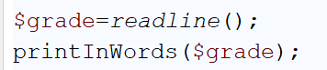

Then create the function and make the if statements for each case: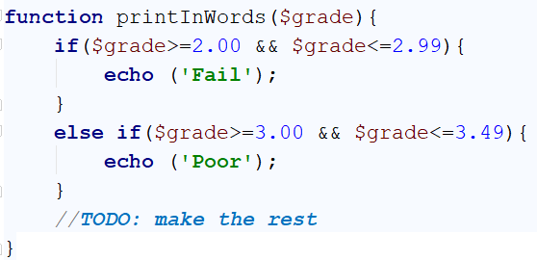

## Calculations

Write a program that receives a string on the first line (**add**, **multiply**, **subtract**, **divide**) and on the next two lines receives two numbers. Create **four functions (for each calculation)** and invoke the right one depending on the command. The function should also print the result.

### Example

|  |  |
| --- | --- |
| **Input** | **Output** |
| subtract  5  4 | 1 |
| divide  8  4 | 2 |

**Hints**

Read the command on the first line and the two numbers, and then make an if/switch statement for each type of calculation

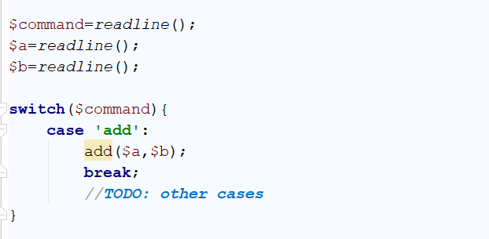

Then create the four functions and print the result.

## Printing Triangle

Create a function for printing triangles as shown below:

### Examples

|  |  |
| --- | --- |
| **Input** | **Output** |
| 3 | 1  1 2  1 2 3  1 2  1 |
| 4 | 1  1 2  1 2 3  1 2 3 4  1 2 3  1 2  1 |

**Hints**

1. After you read the input
2. Start by creating a function **for printing a single line** from a **given start** to a **given end**. Choose a **meaningful name** for it, describing its purpose:

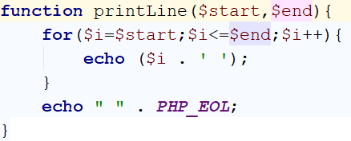

1. Think how you can use it to solve the problem
2. After you spent some time thinking, you should have come to the conclusion that you will need two loops
3. In the first loop you can print the first half of the triangle without the middle line:

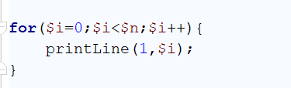

1. Next, print the middle line:



1. Lastly, print the rest of the triangle:

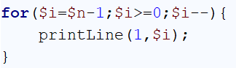

## Orders

Write a function that calculates the total price of an order and prints it on the console. The function should receive one of the following products: **coffee**, **coke**, **water**, **snacks**; and a **quantity of the product**. The prices for a single piece of each product are:

* coffee – 1.50
* water – 1.00
* coke – 1.40
* snacks – 2.00

Print the result **rounded to the second decimal place**.

### Example

|  |  |
| --- | --- |
| **Input** | **Output** |
| water  5 | 5.00 |
| Coffee  2 | 3.00 |

**Hint**

* Read the first two lines
* Create a function the pass the two variables in
* Print the result in the functions

# Returning Values

## Calculate Rectangle Area

Create a function that calculates and **returns** the [area](http://www.mathopenref.com/trianglearea.html) of a triangle by given width and length:

### Examples

|  |  |
| --- | --- |
| **Input** | **Output** |
| 3  4 | 12 |

## Math Power

Create a function that calculates and returns the value of a number raised to a given power:

### Examples

|  |  |
| --- | --- |
| **Input** | **Output** |
| 2  8 | 256 |
| 3  4 | 81 |

**Hints**

1. As usual, read the input
2. Create a function which will have two parameters - the number and the power

## Factorial

You are given number n as input. Your task is to write an **assigning anonymous function** that calculate n factorial and return it.

### Constrains

* The integer **n** will be in **range** **[0, 100]**.

### Examples

|  |  |
| --- | --- |
| **Input** | **Output** |
| 1 | 1 |
| 5 | 120 |
| 25 | 15511210043330985984000000 |

## Multiply Evens by Odds

Create a program that reads an **integer number** and **multiplies the sum of all its even digits** by **the sum of all its odd digits**:

### Examples

|  |  |  |
| --- | --- | --- |
| **Input** | **Output** | **Comments** |
| 12345 | 54 | 12345 has **2 even digits** - 2 and 4. Even digits has **sum of 6**.  Also it has **3 odd digits** - 1, 3 and 5. Odd digits has **sum of 9**.  **Multiply 6 by 9** and you get **54**. |
| -12345 | 54 |  |

### Hints

1. Create a function with a **name describing its purpose** (like getMultipleOfEvensAndOdds). The function should have a **single integer parameter** and an **integer return value**. Also, the function will call two other functions:

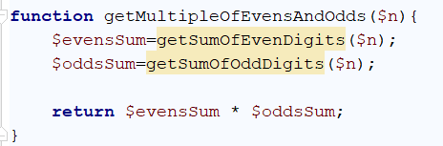

1. Create a function getSumOfEvenDigits**()**
2. Create getSumOfOddDigits**()**
3. As you test your solution you may notice that it doesn't work for negative numbers. Following the program execution line by line, find and fix the bug (**hint: you can use** abs())

## Repeat String

Write a function that receives a string and a repeat count n (integer). The function should return a new string (**the old one repeated n times**)

### Example

|  |  |
| --- | --- |
| **Input** | **Output** |
| abc  3 | abcabcabc |
| String  2 | StringString |

**Hints**

Firstly read the string and the repeat count n

Then create the function and pass it the variables

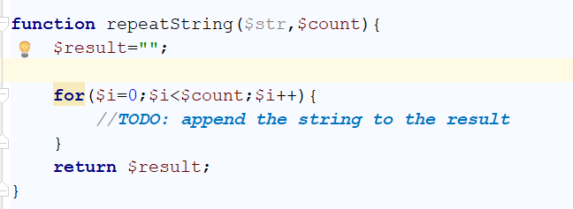

## Math operations

Write a function that receives two number and an operator, calculates the result and returns it. You will be given three lines of input. The first will be the **first number**, the second one will be the **operator** and the last one will be the **second number**. The possible operators are: "/", "*", "+", "-"

Print the result **rounded up to the second decimal point**.

### Example

|  |  |
| --- | --- |
| **Input** | **Output** |
| 5  *  5 | 25.00 |
| 4  +  8 | 12.00 |
| 7  /  2 | 3.50 |

**Hint**

Read the inputs and create a function that returns a floating point number (the result of the operation)

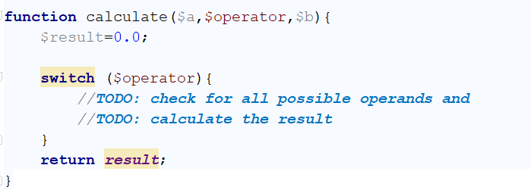

# Forms

## Hello, Person!

Write a program which receives a **name** from a **form** and prints in the html the **following** **greeting** (after your click on the **[Submit]** button). The **form** should **disappear** after clicking the input:

* "Hello, {name}!"

You should read the name from the following form:

|  |
| --- |
| <**form**>  Name: <**input type="text" name="person"** />  <**input type="submit"** /> </**form**> |

### Examples

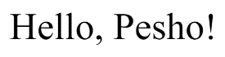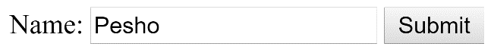

## Multiply Two Numbers

You are given an integer number num1 and an integer number num2. Write a PHP script that multiplies num1 * num2 and prints the result. The input comes as parameters named num1 and num2.  
Print the output in the HTML page.

### Skeleton

|  |
| --- |
| <!DOCTYPE **html**> <**html lang="en"**> <**head**>  <**meta charset="UTF-8"**>  <**title**>PHP Form</**title**>  </**head**> <**body**> <**form**>  N: <**input type="text" name="num1"**/>  M: <**input type="text" name="num2"**/>  <**input type="submit"**/> </**form**> *<!--Write your PHP Script here-->* </**body**> </**html**> |

### Examples

|  |  |  |  |  |  |
| --- | --- | --- | --- | --- | --- |
| **Parameters names** | **Input** | **Output** |  | **Input** | **Output** |
| num1 | 2 | 6 | 13 | 169 |
| num2 | 3 | 13 |

### Hints

* This time the form which will be given to use will have 2 input elements, with names num1 and num2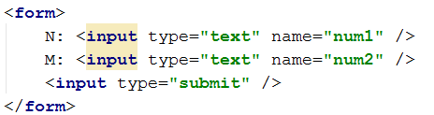
* We must check both elements, if they have values before we perform any action

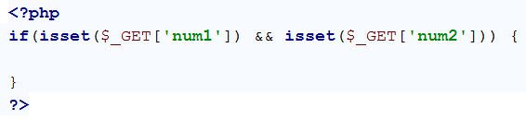

* When we have checked both elements we get them both and extract their values into variables and we perform the specified action:

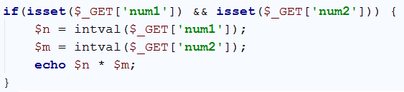

* The result is as follows:
* 
* 